Answer key

**Student name: ............................................. ID: .....................................**

1. **Mention the Scientific term for each of the following: (2.5 marks)**
2. A dry fruit formed from monocarpellary ovary which splits along ventral suture only.
3. An indehiscent fruit formed of mono carpel whosepericarp and testa of its seed are fused together.
4. An indehiscent fruit whose pericarp extend to form membranes or wings.
5. A succulent fruit with a leathery epicarp and woody endocarp.
6. A fruit derived from a scaly flower inflorescence.

**Answer:**

|  |  |  |  |  |
| --- | --- | --- | --- | --- |
| **1** | **2** | **3** | **4** | **5** |
| True simple dry dehiscent follicile | True simple dry indehiscent caryopsis (grain) | True simple dry indehiscent samara | True simple succulent drup | Composite strobile fruit |

1. **Look at the following picture the complete the following sentences:**

**(2.5 marks)**

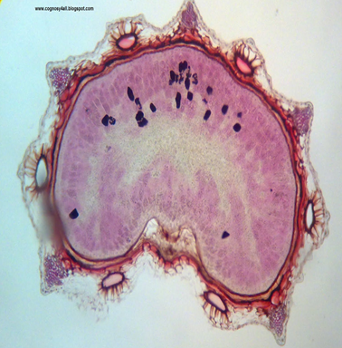

* The above transverse section is of ......1......... fruit whose Arabic name is ....................2...........
* The arrow is pointing to ...........3...... that can be defined as ................................4...............................
* It is mainly used for treatment of .........5........, alopecia and psoriasis

**Answers:**

|  |  |
| --- | --- |
| **No.** | **Answer** |
| 1 | Ammi majus |
| 2 | بذر الخلة الشيطاني |
| 3 | Vittae |
| 4 | Schizogenous ducts lined by epithelium cells and secreting both oil and resin |
| 5 | Vitiligo (lekodermia) |

**Thank you,**

**Dr. Nagwan Gabr**