Answer key

**Student name: ............................................. ID: .....................................**

1. **Mention the Scientific term for each of the following: (2.5 marks)**
2. A dry fruit formed from monocarpellary ovary which splits along both dorsal and ventral sutures.
3. A dehiscent fruit formed of two or more united carpels that splits open to release the seeds through a small cap on its surface
4. A bi or multi seeded indehiscent fruit that has hard woody pericarp
5. A fruit with a fleshy pericarp and having many seeds embedded in is endocarp
6. A fruit derived from mature ovary or ovaries of a single flower, accompanied by other parts of the same flower which on ripening become usually swollen and fleshy

**Answer:**

|  |  |  |  |  |
| --- | --- | --- | --- | --- |
| **1** | **2** | **3** | **4** | **5** |
| True simple dry dehiscent legume | True simple dry dehiscent capsule that open by lid (pyxis) | True simple dry indehiscent nut | True simple succulent berry | False fruit |

1. **Look at the following picture the complete the following sentences:**

**(2.5 marks)**

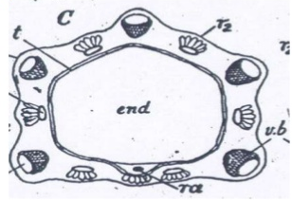

* The above transverse section is of ......1......... fruit whose kind is ....................2...........
* The arrow is pointing to ...........3...... that accompany the bi-collateral fibrovascular bundles.
* Its main active constituents are ..............4......... , ........5...........and traces of furanocoumarins

**Answers:**

|  |  |
| --- | --- |
| **No.** | **Answer** |
| 1 | Ammi visnaga |
| 2 | True simple dry schizocarpic cremocarp formed of two mericarp |
| 3 | Lacuna (empty vittae) |
| 4 | Furanochromones |
| 5 | pyranocoumarins |

**Thank you,**

**Dr. Nagwan Gabr**