1. **Match each photo in column A to the word that describes it in column B: (2.5 marks)**

|  |  |
| --- | --- |
| **Column A** | **Column B** |
|  | 1. Orthotropus ovule |
|  | 1. Curved embryo |
| 1. **3** | 1. Arillus |
|  | 1. Straight embryo |
| 1. 3 | 1. Campylotropus ovule |
| 1. Awn |
| 1. Amphitropus ovule |
| 1. Accumbent embryo |

**Answer:**

|  |  |  |  |  |  |
| --- | --- | --- | --- | --- | --- |
| **Column A** | **1** | **2** | **3** | **4** | **5** |
| **Column B** | a | c | d | e | h |

1. **Look at the following picture the complete the following sentences:**

**(2.5 marks)**

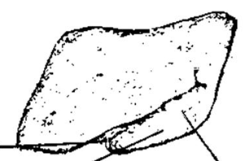

* The above seed was proven to have ............1.........effect and thus is contraindicated in pregnant women.
* The kind of the above seed is ...........2.............
* The above seed contains alkaloids like; ..........3a......., .....3b......... and ................3c..........

**Answers:**

|  |  |
| --- | --- |
| **No.** | **Answer** |
| 1 | Oxytocic |
| 2 | Albuminous |
| 3a | Choline |
| 3b | Trigonilline |
| 3c | Gentianine |

**Thank you,**

**Dr. Nagwan Gabr**