1. **Match each photo in column A to the word that describes it in column B: (2.5 marks)**

|  |  |
| --- | --- |
| **Column A** | **Column B** |
|  | 1. Anatropus ovule |
|  | 1. Orthoplocus embryo |
|  | 1. Arillus |
|  | 1. Accumbent embryo |
|  | 1. Campylotropus ovule |
| 1. Awn |
| 1. Amphitropus ovule |

**Answer:**

|  |  |  |  |  |  |
| --- | --- | --- | --- | --- | --- |
| **Column A** | **1** | **2** | **3** | **4** | **5** |
| **Column B** | g | f | b | a | d |

1. **Look at the following picture the complete the following sentences:**

**(2.5 marks)**

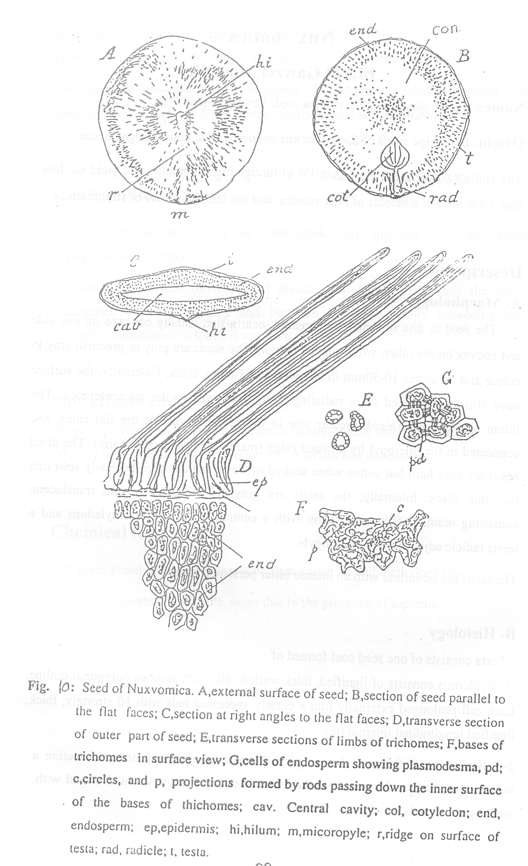

* When making L-cut in the above seed, you shall observe ...........1..........., ..........2................ cotolydons.
* In large doses, such a seed can cause death due to .................3.......
* The above seed contains a major class of alkaloids including ..........4a................ and ................4b......... and a minor one.

**Answers:**

|  |  |
| --- | --- |
| **No.** | **Answer** |
| 1 | Two |
| 2 | cordate leaf like |
| 3 | Asphyxiation (respiratory convulsion) |
| 4a | Strychnine |
| 4b | Brucine |

**Thank you,**

**Dr. Nagwan Gabr**