Biochemistry Quiz
Name: ID:

- Convert 2P glycerate to Lactate showing the names of the intermediates, enzymes and coenzymes (3 marks).
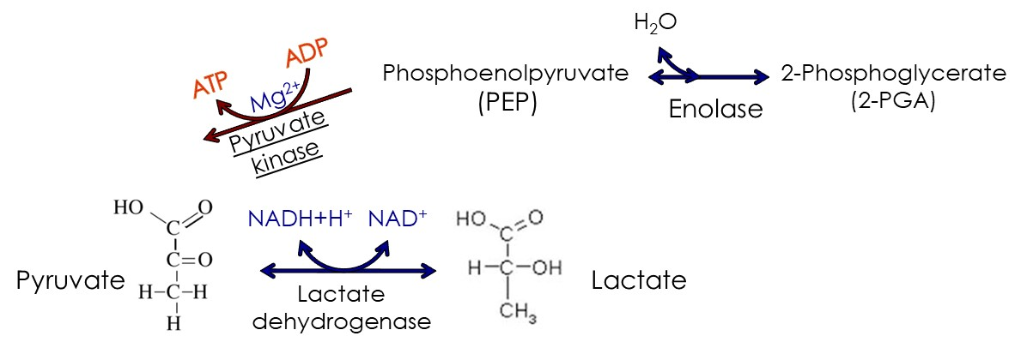

- Krebs cycle can only occur under aerobic conditions, why? (3 marks)
In Krebs cycle energy is obtained from the oxidative phosphorylation which means that the 3NADHs and 1FADH2 produced must be oxidized back to NAD and FAD which is also essential for the cycle to go on. Under anaerobic conditions this will not happen and thus all NADs and FADs will be consumed and the cycle will stop.

- How many ATPs would be obtained from the complete oxidation of a C10 fatty acid? (Show your steps not the reactions) (4 marks)
C10 = 5 acetyl CoA 5x12=60 ATP
C10= 4 cycles Each cycle = NADH+H + FADH2 =5 ATP then 4x5=20ATP
Activation=-2ATP
Total ATP = 79

